Forecasting and predicting stock value using machine learning

##### **Aditya Surana, Mohit Kumar, Anish Shrestha, Prabin Biswakarma**

Department of Information Science and Engineering, FET Jain (Deemed to be university)

Ramanagara District, Karnataka 562112, India

***Abstract*-** Stock Market is considered the primary indicator of a country’s economic strength and development and it is popular and important topic in financial and academic studies. Stock Market is volatile place since there are no significant to estimate price. Stock price are affected by factor like inflation, economic, growth, etc. It is highly depending upon demand and supply. High demanded stock will increase in price whereas heavily sold stock will decrease in price. Many methods like technical analysis, fundamental analysis, time series analysis and statical analysis are used to predict the price of stock market but none of this method are proved as a consistently acceptable to predict stock price. In this paper, we implemented Long short-term memory (LSTM) model to predict stock price. LSTM are effectively implemented in forecasting stock price, return. We focus on a certain parameter with a relatively significant impact on a stock price of a company. Although stock price can never be predicted with 100% accuracy due to many factors, this paper aims at proving the efficiency of Long Short-term memory for stock price.

***Keywords***- Long short-term memory, stock price prediction, machine learning, time series analysis.

1. **Introduction**

The stock market refers to public markets that exist for issuing, buying and selling stocks that trade on a stockexchange or over-the-counter. It involves trading between two investors and it is also known as secondary market. In stock market prediction, the aim is to predict the future value of the financial stocks of a company.

Predicting how the stock market will perform is one of the most difficult things to do. Intrinsic volatility in the stock market across the globe makes the task of prediction challenging. There are so many factors involved in the prediction – physical factors vs. technical, rational and irrational behavior, etc. All these aspects combine to make share prices volatile and very difficult to predict with a high degree of accuracy. Using features like the latest announcements about an organization, their quarterly revenue results, etc., machine learning techniques have the potential to unearth patterns and insights we didn’t see before, and these can be used to make unerringly accurate predictions.

The recent trend in stock market prediction technologies is the use of machine learning which makes predictions based on the values of current stock market indices by training on their previous values. Machine learning itself employs different models to make prediction easier and authentic. The paper focuses on the use of regression and LSTM based machine learning to predict stock values.

A correct prediction of stocks can lead to huge profits for the seller and the broker. Frequently, it is brought out that prediction is chaotic rather than random, which means it can be predicted by carefully analyzing the history of respective stock market. Machine learning is an efficient way to represent such processes. It predicts a market value close to the tangible value, thereby increasing the accuracy. Introduction of machine learning to the area of stock prediction has appealed to many researches because of its efficient and accurate measurements.

**Proposed Solution:**

**Current prices of the stocks**: Generally prices vary from day to day on a fixed amount or at a constant rate. These are the type of general mutual funds where amount if invested, will be compounded manually. This is not of specific interest as there is nothing use of a machine to guess the future price. Just a calculator is enough.

**Technical Analysis Methods:** Method of guessing the correct time to purchase stock pricing. The reason behind technical analysis is that share prices move in developments uttered by the repetitively altering qualities of investors in answer to different forces. The technical data such as price, volume, peak and bottom prices per trade-off period is used for graphic representation to forecast future stock activities.

**Fundamental Analysis Techniques:** This practice uses the theory of the firm foundation for preferred-stock selection. Data of fundamental analysis can be used by forecasters for using this tech of prediction for having a fully clear idea about the market or for investment. The growth, the bonus payout, the IR, the risk of investing so on are the standards that will be used to get the real value for an asset in which they could finance in the market. The main target of this process is to determine the inherent value of strength.

**Long short-term memory (LSTM):** LSTM’s are widely used for sequence prediction problems and have proven to be extremely effective. The reason they work so well is because LSTM is able to store past information that is important, and forget the information that is not. LSTM has three categories:

**The Input gate:** The input gate adds information to the cell state.

**The Forget gate:** It removes the information that is no longer required by the model.

**The Output gate:**Output gate at LSTM selects the information to be shown as output.

**Data visualization:** Data visualization is the practice of translating information into a visual context, such as a map or graph, to make data easier for the human brain to understand and pull insights from. The main goal of data visualization is to make it easier to identify patterns, trends and outliers in large data sets. The term is often used interchangeably with others, including information graphics, information visualization and statistical graphics. In Our Project data visualization is used to track milk quality on a monthly basis so that the farmer could have a clear idea of milk quality and appropriate methods to be taken to improve milk quality

**Data Preprocessing:** Data Preprocessing is that step in which the data gets transformed, or Encoded, to bring it to such a state that now the machine can easily parse it. In other words, the features of the data can now be easily interpreted by the algorithm.

**Related Work**

From the literature survey it is observed that the application of machine learning technique to predict the stock price is being undertaken throughout the world.

Ishita Parmar, Navanshu Agarwal, Himanshu Dhiman, Shikhin Gupta[1] in their paper predicted the future value of the financial stocks of a company. The recent trend in stock market prediction technologies is the use of machine learning which makes predictions based on the values of current stock market indices by training on their previous values. Machine learning itself employs different models to make prediction easier and authentic. The paper focuses on the use of Regression and LSTM based Machine learning to predict stock values.

M. Billah, S. Waheed and A. Hanifa[15] predicted stock prediction using neural networks through the use of a training algorithm which they designed on their own.

Xu Jiawei, Tomohiro[20] ,author proposed the feature selection for selecting useful stock indexes. The model worked on Quantitative & Qualitative data by using Long Short Term Memory (LSTM).

Rachna Sable, Dr. Shivani Goel, Dr. Pradeep Chatterjee[5] used Machine learning and Deep learning algorithms used for stock prediction details about widely used datasets, various evaluation metrics , and features used in the stock market are discussed and number of technical Indicators used for stock market prediction over different periods are highlighted in this research paper.

Tarun Kumar Madan, Jitendra Kumar, Ashutosh Kumar Singh[8] used machine learning algorithms such as support vector machine, deep learning, random forest, boosted decision trees, ensemble methods and a few hybrid methods which have been used to build prediction model and predict the stock prices for different stock exchanges. They have also covers the various challenges that are encountered while building prediction models.

Batra et al [14] have proposed a different way of using the SVM algorithm. In their paper, they have extracted the sentiment from twitter using StockTwits via a pipeline API of python. The data extracted using the former was preprocessed for sentiment analysis and Natural Language Processing (NLP). SVM is used to predict the sentiment of each data and then classifying the tweets into positive and negative tweets for easier and better prediction models. The output of this is then combined with the available historical data and used for stock price prediction.

**Literature Survey**

|  |  |  |  |  |  |  |
| --- | --- | --- | --- | --- | --- | --- |
| S.No | Title | Authors | Year of  Publication | Type of data | Methodology | Limitation |
| 1. | Stock market prediction using machine learning | Ishita Parmar, Navanshu Agarwal, Himanshu Dhiman, Shikhin Gupta | 2018 | Research Paper | Regression based model to predicting continuous values through some given Independent values | It assumes that the data is independent |
| 2. | Stock price prediction using reinforcement learning | Jae Won Lee | 2010 | Research paper | Reinforcement learning | Reinforceme nt learning needs a ton of data or epochs |
| 3. | Machine learning techniques and use of event information for stock market prediction | Paul D. Yoo, Maria H. Kim, Tony Jan | 2005 | Research paper | Neural networks has the ability to learn Relationship through the data itself | Neural networks usually require much more data than traditional machine learning algorithms |
| 4. | A machine learning model for stock market prediction | Osman Hegazy, Omar S. Soliman, Mustafa Abdul Salam | 2013 | Research paper | Regression based model to predicting continuous values through some given Independent values | It assumes that the data is independent |
| 5. | Empirical study on stock market prediction using machine learning | Rachna Sable, Dr. Shivani Goel, Dr. Pradeep Chatterjee | 2018 | Research Paper | Fuzzy dual-factor time-series for stock index forecasting | It takes volume to make price move |
| 6. | Stock market prediction analysis by incorporating social and news opinion and sentiment | Zhaoxia Wang, Seng -Beng HO Zhiping Lin | 2018 | Research Paper | Artificial Neural Network methods are mostly implemented and play a vital role in decision making for stock market predictions | ANN, It wi give  less accurat results |

**Architecture Diagram**

Data Processing

LSTM

Build Model

MinMaxScaler

Dataset

Validation

Data Split

TimeSeriesGenerator

Testing

Output Test

Output Prediction

Prediction

Testing

Plot

Plot

**Result**

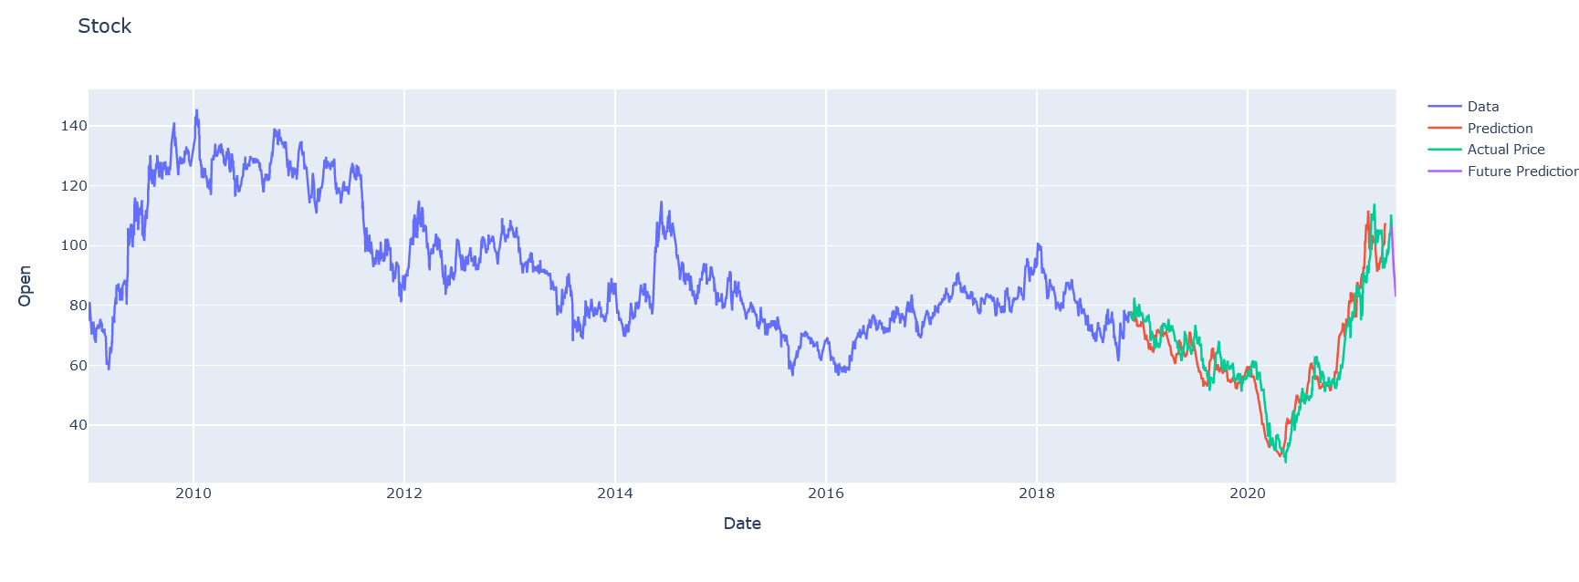

**Fig. LSTM**

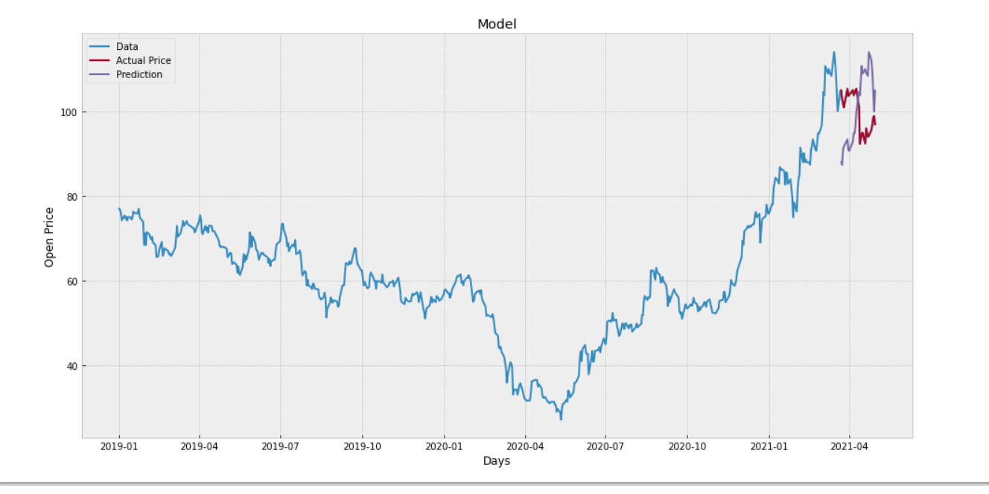

**Fig. Linear Regression**

**Conclusion**

We have studied different methodologies for stock market prediction which will help the investor for making the correct decision for buy or sell the stocks. Each method has some limitations.

In this study, stock market basics are discussed and then the need for predicting the future stock market prices. Few of the approaches which may be used for stock market prediction like Non-linear regression analysis, Hidden Markov Model, Artificial Neural Networks, Naïve Bayes Classifier, Decision Trees Classifier, Random Forest Method, Support Vector Machines, PCA (Principal Component Analysis), WB-CNN (Word embeddings input and convolutional neural network prediction model) and CNN (Convolutional Neural Network) are elaborated in this paper. Results of this research are beneficial in concluding that LSTM (Long Short-Term Memory) Neural network has better results in comparison to other methods.

We made an attempt to evaluate different methods of forecasting the stock market trends by which any investor can find the best method by which they can predict the stock market much more accurately then previously done methods.

**References**

1. Ishita Parmar, Navanshu Agarwal, Himanshu Dhiman, Shikhin Gupta “Stock market prediction using machine learning” , IEEE 2018.
2. Jae Won Lee “Stock price prediction using reinforcement learning “, IEEE 2010
3. Paul D. Yoo, Maria H. Kim, Tony Jan “Machine learning techniques and use of event information for stock market prediction”, IEEE 2005
4. Osman Hegazy, Omar S. Soliman, Mustafa Abdul Salam “A machine learning model for stock market prediction”, IEEE 2013
5. Rachna Sable, Dr. Shivani Goel, Dr. Pradeep Chatterjee “Empirical study on stock market prediction using machine learning”, IEEE 2018
6. Zhaoxia Wang, Seng-Beng HO, Zhiping Lin “Stock market prediction analysis by incorporating social and news opinion and sentiment”, IEEE 2018
7. Pawee Werawithayaset, Suratose Tritilanunt “Stock closing price prediction using machine learning”, IEEE 2019
8. Tarun Kumar Madan, Jitendra Kumar, Ashutosh Kumar Singh “Stock market forecasting today and tomorrow “, IEEE 2019
9. Subhadra Kompella, Kalyana Chakravarthy Chilukuri “Stock market prediction using machine learning methods”, IEEE 2019
10. Radu Iacomin “Stock market prediction”, IEEE 2015
11. Ashwini Pathak “Study of machine learning algorithms for stock market prediction”, IEEE 2000
12. Jingyi Shen and M. Omair Shafiq ”Short‐term stock market price trend prediction using a comprehensive deep learning system”, IEEE 2020
13. Ashish Sharma, Dinesh Bhuriya, Upendra Singh “Survey of stock market prediction using machine learning approach “, IEEE 2017
14. R. Batra and S. M. Daudpota: "Integrating StockTwits with sentiment analysis for better prediction of stock price movement,", IEEE 2017
15. Pushpendu Ghosha, Ariel Neufeldb, Jajati Keshari Sahoo “Forecasting directional movements of stock prices for intraday trading using LSTM and random forests”, IEEE 2015.
16. Ibrahim M. Hamed, Ashraf S. Hussein, Mohamed F. Tolba “An intelligent model for stock market prediction ”, IEEE 2012

19)Weng, B., Ahmed, M. A., & Megahed, F. M. “Stock market one-day ahead movement prediction

using disparate data sources.”, IEEE 2017

20) Xu Jiawei, Tomohiro Murata “Stock market trend prediction with sentiment analysis based on LSTM

neural newtwork” IEEE 2019